**Data Report: Terry Stop Analysis**

**1. Introduction**

Terry Stop is a detention practice by the police whereby a police officer stops an individual based on a reasonable amount of suspicion that criminal activity might be occurring. A Terry Stop grants the officer the right to briefly stop the individual for questioning and allows them even to frisk the individual for any weapons if there is suspicion that the person is armed. The key goals of this analysis include determining how race, gender, and age can predict whether someone is stopped or arrested, as well as assessing the overall efficiency of stops. This analysis also tries to examine if some areas-i.e., precincts or sectors-exhibit higher levels of biased or inefficient policing.

This report aims to develop actionable insights from the emerging patterns of Terry Stops across demographics and regions to help reform policing practices with a view to reducing disparities and increasing the equity and effectiveness of law enforcement activities.

**2. Data Overview**

The dataset contains 61,980 records and includes 23 feature variables related to the subjects and officers involved in the Stops. These datasets range from the demographic information of both the subjects and the officers to the details of what happened concerning an individual stop, including precinct and sector, outcome of stop-arrest, summons, or simply field contact.

This dataset is rich in capturing various dimensions of each encounter and as such is suitable for investigating potential disparities in policing based on different characteristics. Variables include demographic characteristics of subjects and officers, such as age, gender, and race; stop resolution, such as arrest or summons; and several geographic identifiers, including precinct, sector, and beat of occurrence. These variables provide a great insight into how proper policing practices vary across groups and areas.

**2.1 Important Variables**

First, the data set contains several variable types that are important for this analysis:

* Subject Characteristics: These are characteristics of the stopped individuals, which consist of Age, Gender, and Race. The age would be categorized as groups to understand if there would be an analysis of specific age groups that are more at risk of getting stopped by the police.
* Officer Characteristics: This defines the variables related to the officers performing the stop. Important variables include, among others, Gender, Race, and Year of Birth. This kind of demographic data gives way for any analyses as to whether officer demographics might make them target particular races or gender over another.
* Stop Details: This contains nature stop variables, including Stop Resolution, showing whether a summons or arrest was made, or it was only a field contact. Officer Squad, Precinct, Sector, and Beat convey the geography of the stop.
* Outcome: The Arrest Flag and Frisk Flag are the key variables here, showing whether an arrest was made or a frisk was conducted during the stop.

**3. Data Cleaning and Preprocessing**

Before the in-depth analysis, several cleaning steps were done on the dataset to prepare it for modeling.

**3.1 Handling Missing Data**

It should be noted that a number of those columns were missing a whole heap of values; in regards to this, Weapon Type was excluded, having over 90% of missed data. Other columns related to Subject Age Group and Subject Perceived Race, with less missing records, also imputed missing values using Mode, or the most occurring value. Other location-based columns feature Precinct and Sector replaced missing values with "Unknown.".

**3.2 Outlier Detection and Removal**

A box plot was done for the Officer Year of Birth column to detect the outliers, which were removed to avoid having inconsistent data that may distort the analysis.

**3.3 Encoding Categorical Data**

Categorical variables include Subject Perceived Gender, which are encoded using Label Encoding to transform them into a format understandable by machine learning models.

**4. Exploratory Data Analysis**

Here, we dive deep into the dataset in search of patterns and trends. We analyze demographic distributions, effectiveness of stops, and geographic and temporal trends in police practices.

**4.1 Demographic Distribution of Subjects and Officers**

**4.1.1 Subjects' Age Distribution**

First, we wanted to see if some ages were more likely to be stopped than others, so we examined the age distribution across stops. We found that the age groups stopped most were between 26 and 35 years old, followed by those between 36 and 45 years of age. We were surprised that individuals 56 and over were stopped the least, suggesting that police stops disproportionately target younger individuals. This would indicate profiling based on age or an undue concentration on younger subjects.

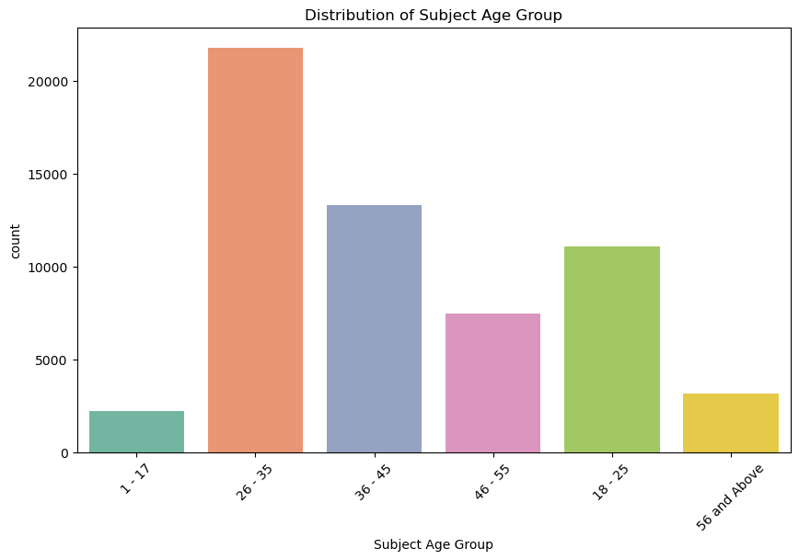

**4.1.2 Distribution of gender among the subjects and officers**

Our analysis continues with the gender-based trends of who is being stopped and by whom. Results indicate that an overwhelming proportion of stops involve male subjects, nearly 85% of the stops in fact. Meanwhile, most stops were by male officers, a possible gendered imbalance in who is being stopped and who does the stopping. This could well reflect an ingrained, perhaps even broader societal gender bias in the police stop practice.

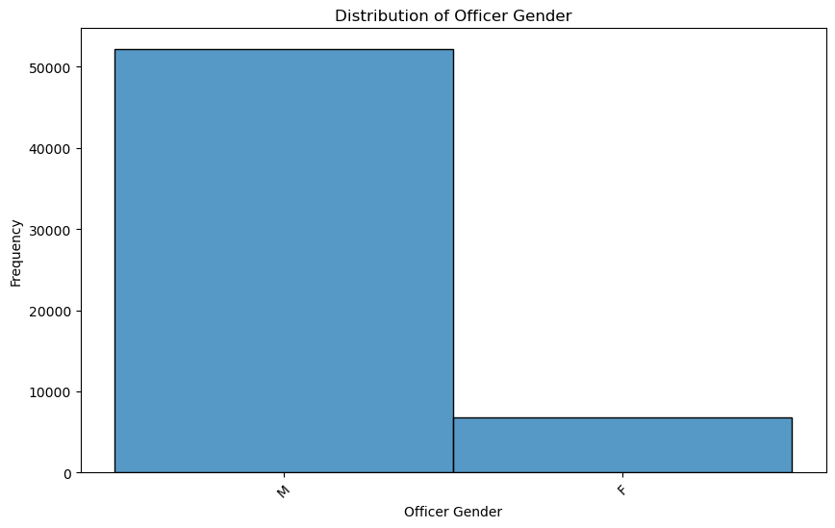

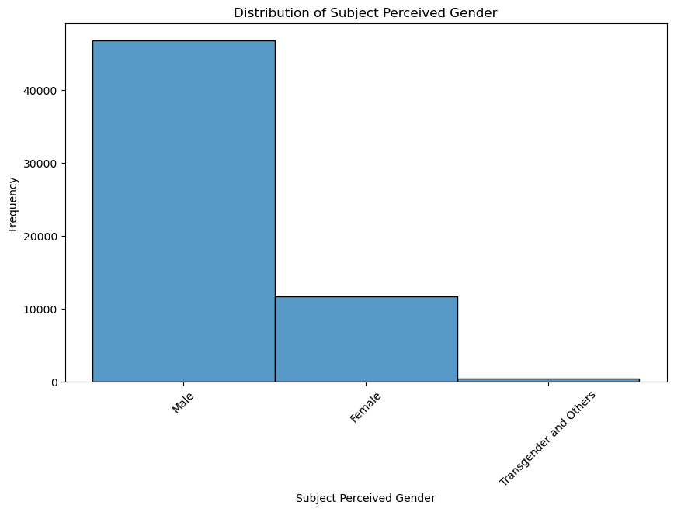

**4.1.3 Race Distribution between Subjects and Officers**

Investigating the potential racial bias in stops: The distribution of officer stops by race is indicative of the following: that white subjects are stopped most, followed by Black or African American people. In terms of officer demographics, the most prevalent was the white officer-a trend most police forces have. It could play a role in how biased interaction between officers and people with different racial groups will pan out and affect a stop that occurs.

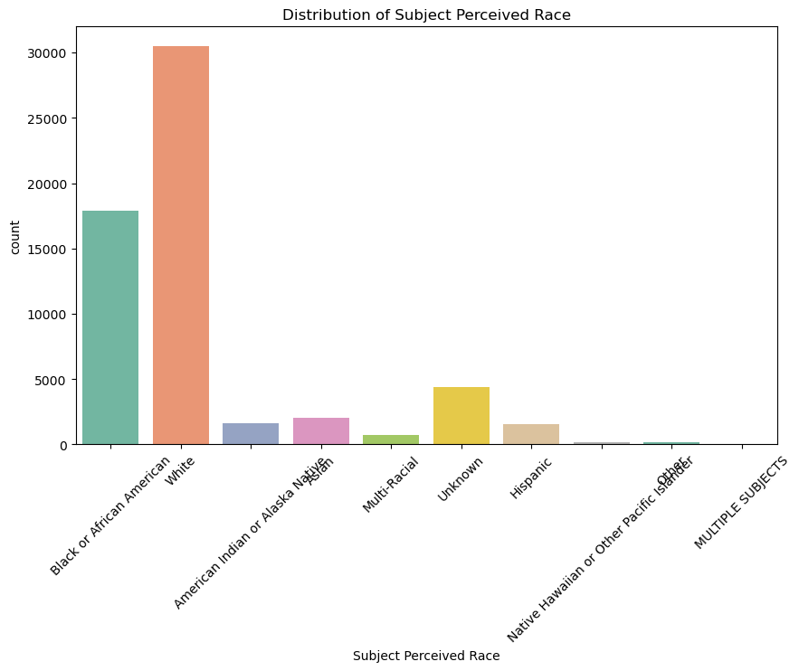

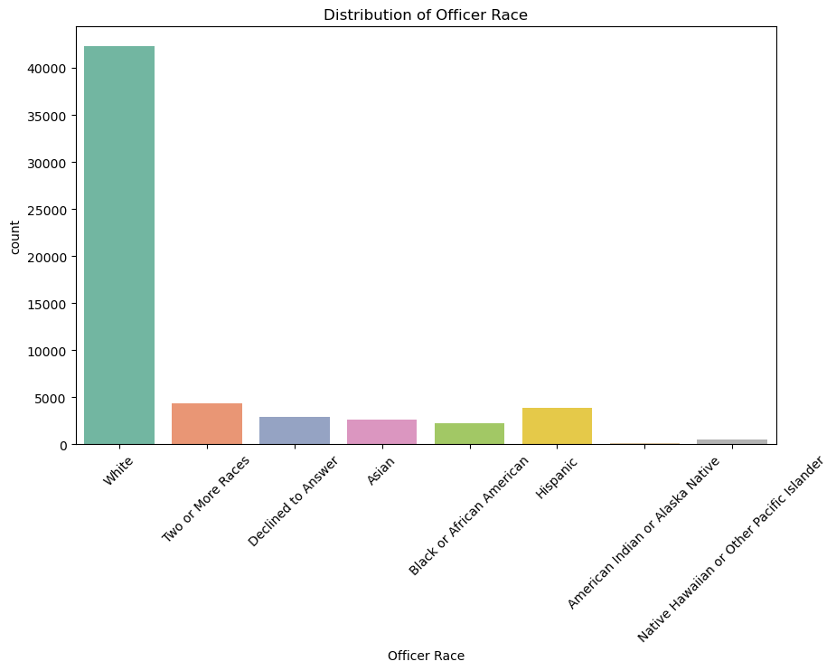

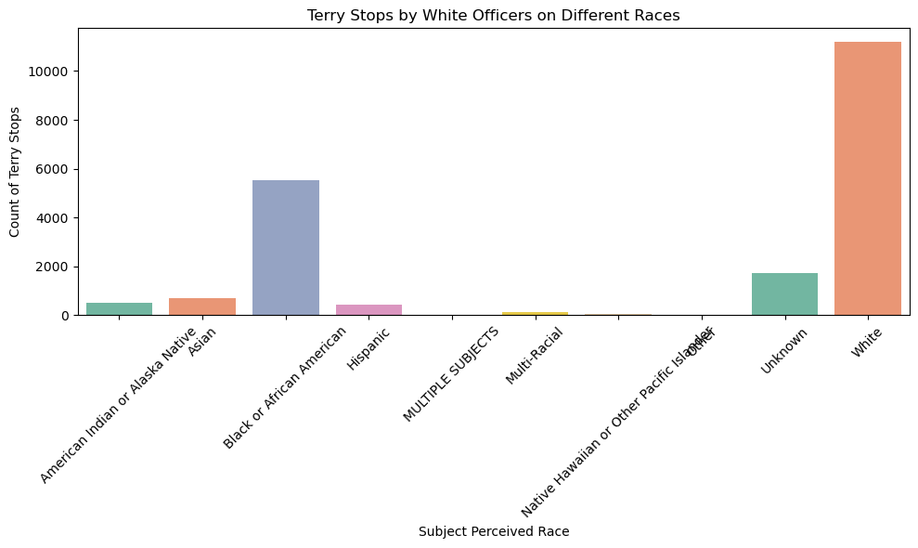

**4.2 Stop Resolution Analysis**

A key part of this analysis is understanding how frequently police stops result in actual outputs, such as arrests or summons. Our findings showed that the majority of stops were simply categorized as Field Contact, in which no formal action was taken. Just about 6% of the stops resulted in an arrest-a reflection of the relatively low likelihood that a stop will escalate to significant legal consequences. This might indicate that, while Terry stops are common, they often do not result in actionable law enforcement consequences.

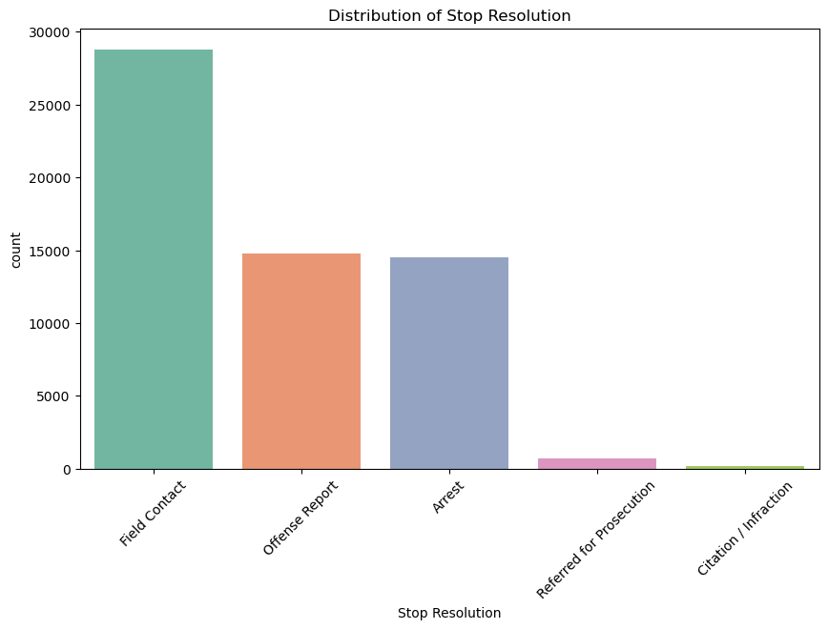

**4.3 Time trends of Stops**

We analyzed the temporal trends in Terry stops to see if there is an increase during certain times or years. Stops significantly increased from 2015 to 2018 and then decreased somewhat in recent years. This may be due to changing law enforcement policy, societal factors, and/or specific events that affected how police patrol. It could be an interesting area for further research to understand why this fluctuation happened.

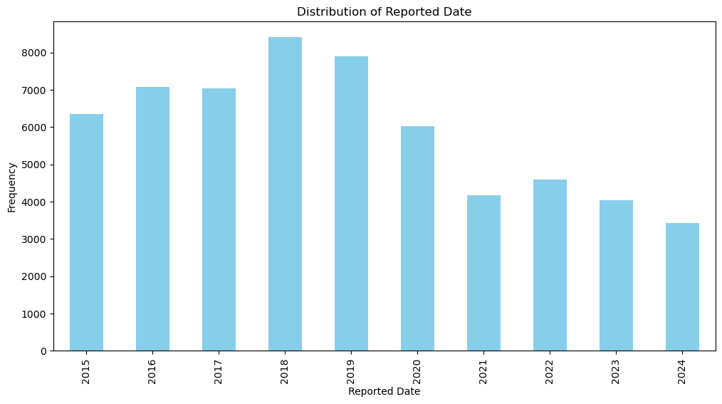

**4.4 Spatial Patterns in Stops**

We have also found rather large geographical variability across the precincts and sectors in stop frequency: the West precinct has the most stops, while other precincts like Southwest and OOJ have considerably fewer frequencies. This pattern indicates that police activity in those areas is more concentrated; hence, it may be questioned whether the respective neighborhoods are over-policed, either because of their natural demographic features or due to perceived criminality.

**5. Statistical and Predictive Modeling**

The purpose of the modeling section is to predict the likelihood of an arrest based on several demographic and situational factors. We adopt two models in this respect: Logistic Regression and Decision Trees.

**5.1 Logistic Regression**

Logistic Regression was used to predict the probability of an arrest based on the features present. It achieved 94% accuracy but failed to predict arrests correctly. The model had much better performance in predicting no arrests (class 'N'); however, precision for the arrest predictions was only 0.79 and recall was 0.77. This can be seen as an indication that there is a scope for further improvement regarding the minority class prediction.

**5.2 Decision Tree**

Decision Tree was chosen because it can capture nonlinear relationships between variables. It performed similarly to Logistic Regression, where it was very accurate at predicting no arrests but had lower performance for predicting arrests. However, Decision Trees are more interpretable and provide insight into how specific features (e.g., age, race, precinct) drive the decision to make an arrest.

**6. Key Findings**

**6.1 Policing Bias**

* Racial Bias: The current analysis pointed out the probable targeting of Black and Hispanic individuals, particularly in those precincts that had the highest police presence.
* Gender Bias: An overwhelming number of those stopped were males, hence indicating gender imbalance in stops.

**6.2 Efficiency of Terry Stops**

* The most common outcome is Field Contact, showing that many stops did not result in arrests or any other active outcome. This also raises concerns about the overall effectiveness of the Terry stop in achieving the goals of law enforcement.

**6.3 Demographics of Officers**

* The demographic composition in terms of race and gender among officers influences their policing practices, particularly towards groups they stop. For sure, the influence of officer demographics on stop patterns is a further area of inquiry.

**7. Recommendations**

* Recommendation 1: Implement Targeted Training Programs for Law Enforcement Officers
* Recommendation 2: Enhance Data Transparency and Accountability
* Recommendation 3: Refine Stop Criteria and Procedures
* Recommendation 4: Utilize Predictive Analytics for Resource Allocation
* Recommendation 5: Regularly Evaluate Policing Practices